Research - Converting quaternion to euler angles

https://www.youtube.com/watch?v=mFpH9KK7GvI&feature=youtu.be

Use Ricardo’s code for reading pose and outputting orientation, but reading IMU instead

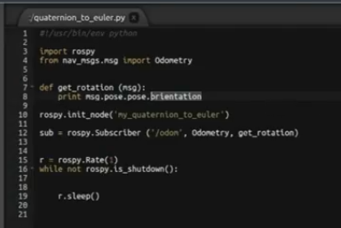

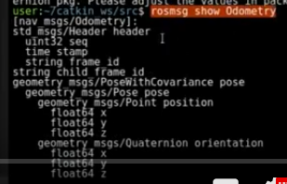 | From nav_msgs.msg import Odometry  ….  print msg.pose.pose.orientation
So I believe mine should be
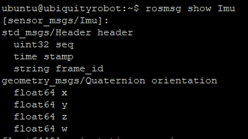 | From sensor_msgs.msg import Imu  C++  ROS_INFO("Imu Orientation x: [%f], y: [%f], z: [%f], w: [%f]", msg->orientation.x,msg->orientation.y,msg->orientation.z,msg->orientation.w);

First find the IMU node and understand the variable names for orientation
- $ roslaunch test_imu test_imu.launch
- In another window look at the structure of the node /tinkerforge_imu_brick2
- $ rosmsg show tinkerforge_imu_brick2

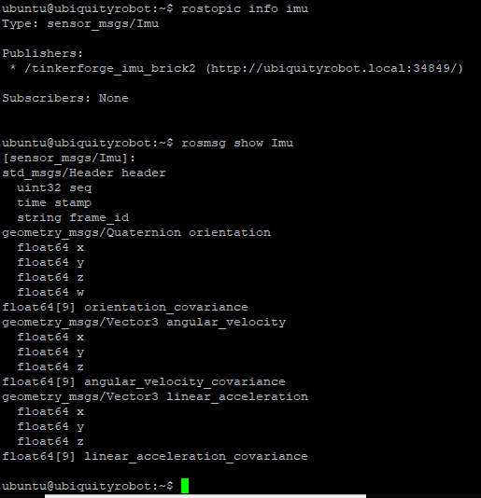

$ rosrun test_imu my_quaternion_step1.py

Errors:
[rosrun] Couldn't find executable named my_quaternion_step1.py below /home/ubuntu/catkin_ws/src/test_imu

Try:
- $ cd /home/ubuntu/catkin_ws/src/test_imu/src
- Use $ chmod +x my_quaternion_step1.py to change the permissions

Notes:
Earle Robotics reference: https://github.com/erlerobot/ros_erle_imu/blob/master/scripts/imu.py

Mentioned by clearrobotics: https://groups.google.com/forum/#!msg/ros-sig-drivers/Fb4cxdRqjlU/QzoMiMn_g3kJ

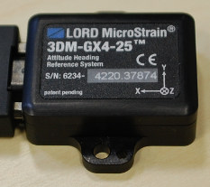 lord microstrain 3dm-gx4-25
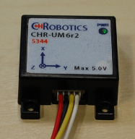 CH Robotics CHR-UM 6r2
Looks to be replaced by: http://www.chrobotics.com/shop/um7-lt-orientation-sensor

Yet another IMU, https://yostlabs.com/product/3-space-embedded-lx/
“....Based on the results from the tests performed on all the MARG sensor modules, the YEI 3-space data-logging sensor exceeded the dynamic accuracy of the 3DM-GX4- 25. Furthermore, the cost of the YEI 3-space data-logging sensor was significantly lower as compared to the 3DM-GX4-25….”, https://calhoun.nps.edu/bitstream/handle/10945/51592/16Dec_Pelachick_Heather.pdf?sequence=1&isAllowed=y

YEI 3-space data-logging sensors:
https://yostlabs.com/wp/wp-content/uploads/pdf/TSS_Family_Tech_Brief_v2.2.1.pdf

